**PHYS 202 … Practice Problems**

**Capacitors Part A**

1. 3.16 pF
2. 4.64 pF

1. 9.71 pF
2. 46.8 pF

1. 11.3 pF
2. 11.3 pF

1. 12.7 pF
2. 6.36 pF

1. 0.149 V
2. 1.67 kV

1. 11.0 nF
2. 430 F

1. 2.68 x 10-8 J
2. 1.31 x 10-5 J

1. 2.13 mF
2. 56.8 F

1. 14.0 pF
2. 19.6 pF

1. 91.9 pF
2. 6.45 nF

1. 18.0 nF
2. 23.7 nF
3. 30.0 nF

1. 17.1 nF
2. 13.8 nF
3. 20.0 nF

1. 75.0 nF
2. 95.0 nF
3. 120 nF

1. 160 nF
2. 140 nF
3. 180 nF

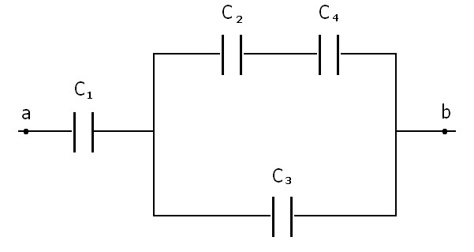

1. 14.3 nF
2. 12.6 nF
3. 13.1 nF
4. 9.35 nF

1. A capacitor is constructed using two parallel rectangular plates that measure 4.84 x 10 – 3 m by 2.43 x 10 – 3 m separated by 7.43 x 10 – 5 m of Polypropylene. Polypropylene has a dielectric constant of 2.20 and a dielectric strength of 7.00 x 10 7 V/m.
   * + 1. 3.08 pF
       2. 5201 V
       3. 4.17 x 107 J

1. 5
2. 4

1. 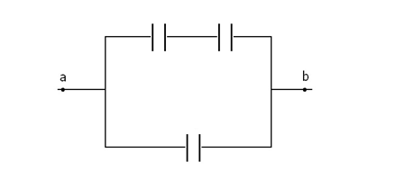
2. 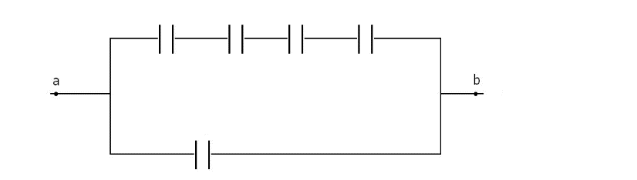
3. 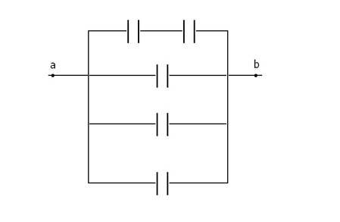
4. 